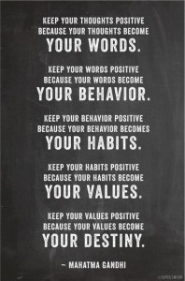
Can be found at https://www.google.com/search?q=adriancahill+gandhi%27s+top+ten+fundamentals+poster&rlz=1C1OPRB___US581US581&espv=2&biw=1366&bih=643&source=lnms&tbm=isch&sa=X&ei=mxMOVOH-LM-lyAS1toCADQ&ved=0CAcQ_AUoAg#facrc=_&imgdii=_&imgrc=uMFzpzeQGovnfM%253A%3Bffk3v3cdAEI8GM%3Bhttp%253A%252F%252Fadriancahill.com%252Fwp-content%252Fuploads%252F2012%252F11%252Fwords-to-ponder-198x300.%3Bhttp%253A%252F%252Fadriancahill.com%252Fself-development%252Fgandhis-top-10-fundamentals-for-changing-the-world%252F%3B198%3B300
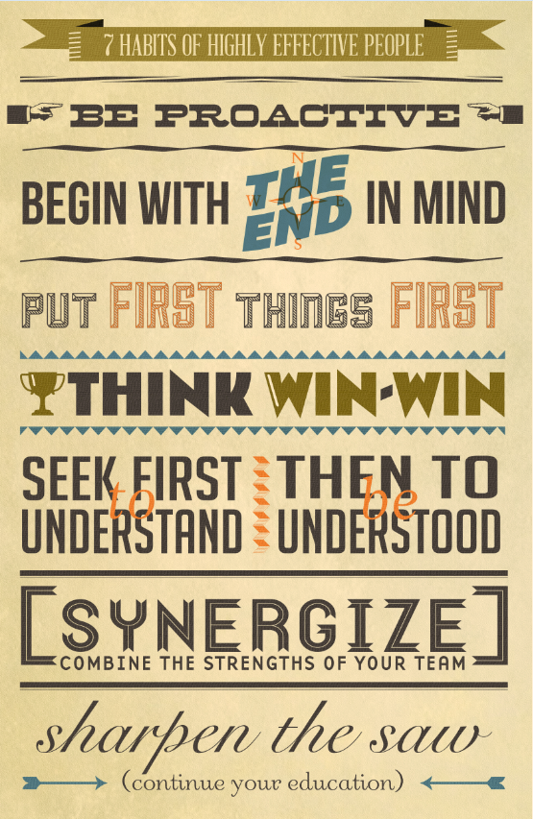

May be found at: https://www.google.com/search?hl=en&site=imghp&tbm=isch&source=hp&biw=1366&bih=600&q=Jake+Hohn+Design+7+Habits+of+Highly+Effective+People&oq=Jake+Hohn+Design+7+Habits+of+Highly+Effective+People&gs_l=img.3...3006.20566.0.21342.52.9.0.43.1.0.77.564.9.9.0....0...1ac.1.53.img..43.9.512.nHhf9DkTedM#facrc=_&imgdii=_&imgrc=NwkxokUR0ouQMM%253A%3BuMJjPxmBLWXuGM%3Bhttp%253A%252F%252Fwww.fengshuidana.com%252Fwp-content%252Fuploads%252F2012%252F08%252FCapture.png%3Bhttp%253A%252F%252Fwww.fengshuidana.com%252F2012%252F08%252F29%252Fthe-7-habits-of-highly-effective-people%252F%3B555%3B853

