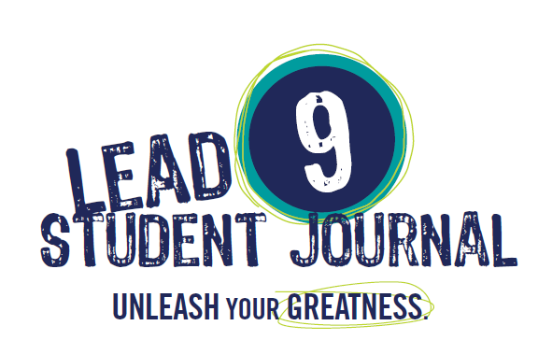

kid∙FRIENDLy High School’s LEAD 9 ONLINE RESOURCES

The LEAD 9 Student Journal and Teacher Edition provide a way to incorporate the 7 Habits into your classrooms.

FranklinCovey has created a Vimeo channel especially for us and it’s up and ready for use. Our channel has the LEAD 9 videos and power points referenced in the LEAD 9 Teacher Editions. References to these online resources are found throughout the LEAD 9 Teacher Edition and designated with an @ symbol.

Please follow these instructions:

The first link will give you access to the videos use the password LEAD9. The power point link is in the description of the video, but it is also included in the second link.

https://vimeo.com/user34436775/albums

Password to access videos: LEAD9

Power point link http://goo.gl/yBmCN0

For additional resources you may want to check out Sean Covey’s website for the Student Voice Finder tool follow this link:
http://www.seancovey.com/teens.html

