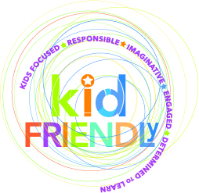

GRREC/OVEC kid-FRIENDLy Project

Spring 2015
COMMUNITY OF LEARNERS Sessions:
AN OPPORTUNITY FOR DISTRICT AND SCHOOL LEADERS
TO LEARN AND LINK

We are pleased to announce the schedule and agenda for the Spring 2015 kid-FRIENDLy Community of Learners (COL) sessions, designed to support district and school-level leaders as you provide local leadership for the kid-FRIENDLY project. These sessions will focus on Project-Based Learning along with other topics indicated below.

As your Teachers Leaders continue their work in the parallel Communities of Practice, the COL sessions are a chance for leaders to learn more about supporting the work already underway and to collaborate on the development and implementation of these and other innovative practices toward kid-FRIENDLy’s overall goal of personalized learning.

Superintendents, principals, district Points of Contact for the project, and other leaders in the grant’s 22 districts are invited to attend the Spring session that best fits their schedules:
March 30th Bowling Green at the Carroll Knicely Conference Center 10:00 to 2:00 (CDT)
March 31st Shelbyville at the Ohio Valley Educational Cooperative (OVEC) 10:00 to 2:00 (EDT)
April 1st Russell Springs at the Russell County Schools Natatorium 10:00 to 2:00 (CDT)

The Spring COL will feature these presenters and topics:
- Drew Perkins, with Perkins Educational Consulting and National Faculty for the Buck Institute for Education, providing an overview of Project-Based Learning (PBL) based on his own experiences teaching in PBL schools and of training teams across the country in a PBL model
- Representatives from kid-FRIENDLy districts who have recently received PBL training speaking about their training experience, about PBL for their districts, and where they see their work going next
- An update on kid-FRIENDLy project drivers with particular emphasis on College and Career Readiness Centers and an Overview of Life-Ready
- Timeline for the continued work of the grant with discussion of support for the school-specific Snapshots
- An opportunity for districts to meet as individual teams to reflect on the information shared and what it may mean for them

Register at https://docs.google.com/forms/d/1xE2q1Kv4IUXuU_qL6dpHoMKsVgVrkG2oqMxyg7tyw-E/viewform?usp=send_form

Registration Deadline - March 20, 2015
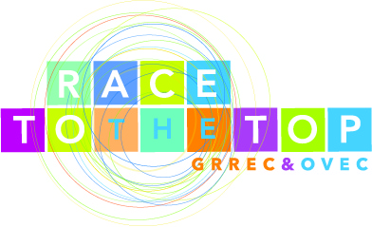
Lunch included for all sessions EILA Credit Available

