Purposeful Play

“Play is the highest form of research.”

It’s not only okay for children to play, but it’s okay for you to play with them! Children learn best as they explore and try to better understand how things work. Their play is enhanced when adults interact in play, posing questions and setting up opportunities for children to look at familiar things in different ways and explore things that are new to them. Learn how to look at what is available for children to explore and then how to join in children’s explorations. You will also discover how your interactions and questioning can help children become more secure and eager learners while developing critical thinking skills! It’s easier than you think!

Presenters: Beth Schaeffer, Preschool Consultant, Warren County Public Schools
Nicole Martin, Occupational Therapist, Warren County Public Schools

Audience: Preschool Teachers, Instructional Assistants, Childcare Teachers of 3s, 4s, and 5s, and Directors

Date/Time: April 24, 2015, 8:30-12:30, CDT
Registration begins 30 minutes before the session start time.
A light breakfast will be served.

Location: Carroll Knicely Conference Center, 654 Campbell Ln., Bowling Green, KY 42101

Cost: No Cost to Kid Friendly Preschool Centers and Participating Districts
(No cost to participants from these districts due to their participation in the kid-FRIENDLy grant:
Adair, Campbellsville, Carroll, Caverna, Cloverport, Daviess, Green, Hart, Henry, Logan, Metcalfe, Monroe, Owensboro, Owen, Russell, Shelby, Simpson, Spencer, Taylor, Trimble, Union, and West Point )

Space is limited to 100 participants.
4 Early Childhood Training Hours Available

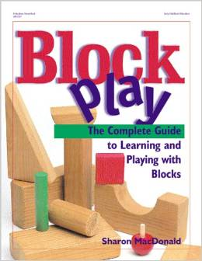
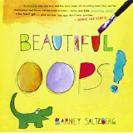
Each participant will receive a copy of the Block Play by Sharon MacDonald and
Beautiful Oops by Barney Saltzberg.
Registration Form
Purposeful Play
April 24, 2015 8:30-12:30 CDT

Please Print:

Name: ___________________________________ Center/District: ________________________________

School: __________________________________ Position:_______________________________________

Phone #: _________________________________ Email __________________________________________

Note: Please cancel your registration within five (5) working days of the activity to allow another participant the opportunity to attend. Substitutions will be allowed.

Registration Deadline: April 20, 2015

`

Complete this form and give to your Kid-FRIENDLy Preschool Pal, or

Fax this completed form to kid-FRIENDLy

Attention: Kim Guffy at (270) 904-0921 (Fax), or

Register Online:
https://docs.google.com/forms/d/1sVqR3jDKBmoTjZ7vxTePAWqRg4ZjuxKFs9VrVgO8Yvc/edit

Sponsored by
Green River Regional Education Cooperative
230 Technology Way, Bowling Green, KY 42101

Questions??
Please contact Allison Bemiss at allison.bemiss@ky.gov or your Kid-FRIENDLy, Preschool PAL

